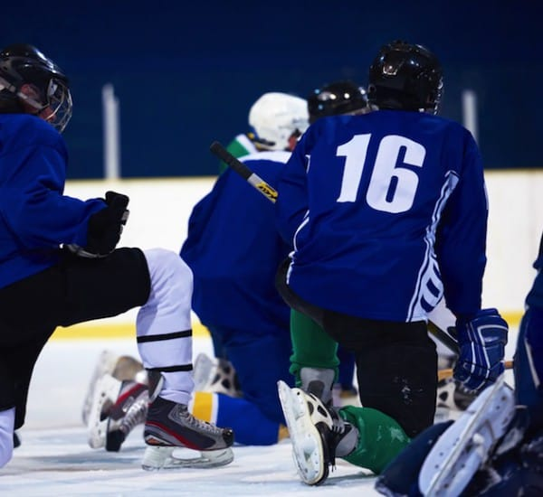

Journey Hockey Academy 2020-21

Hockey Academy for Grade 6,7 & 8 Students

Hockey Academy will be in the timetable and replace the student’s PE class.
- Hockey Academy Students will have 3 Academy Classes per week
- Professional coaches assist the Academy teacher during each class.
- Hockey skills, tactics, fitness and conditioning will be the focus

Costs for registration: $755 for the year
This fee covers the additional coaching, kit, facility rentals and supplies
Registration: please visit the following website for registration information:
https://www.sd62.bc.ca/programs-services/academies
Or call the Academies Office @ 250-391-9006 ext.250 for assistance

